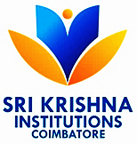
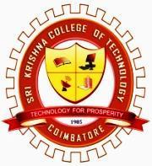
SRI KRISHNA COLLEGE OF TECHNOLOGY
An Autonomous Institution
Affiliated to Anna University and Approved by AICTE
Accredited by NAAC with ‘A’ Grade
KOVAIPUDUR CAMPUS, COIMBATORE – 641 042.

SCHOOL OF COMPUTING SCIENCES
Computer Science and Engineering
CLASS TIME TABLE
Academic Year 2025 -26 EVEN Semester
Sem: VI Class: III Section: C WEF: 23.03.2026
Hour  Day Order | 1  9.15-10.10  AM | 2  10.10-11.05  AM |  | BREAK 11.05 -11.20  AM | 3  11.20-12.15  PM | LUNCH 12.15-1.00 PM | 4  1.00-01.55  PM | 5  01.55-02.50  PM | 6  02.50-03.45  PM
DO 3 | PCD | ML |  |  | AI |  | ML | ML | AI
DO 4 | QC |  | AI |  | ML |  | PCD | AI | PCD
DO 5 | PCD | ML |  |  | QC |  | QC | PCD | QC
DO 1 | QC | QC |  |  | PCD |  | ML | AI | AI

PREPARED BY  Time Table Co-Ordinator |  |  | VERIFIED BY  HoD/CSE | FORWARDED BY  Overall Time Table Co-Ordinator |  | APPROVED BY  Principal
Revision History:
Revision Level |  | Reason for Revision |  |  | Date | Authorized by
From | To

